B.

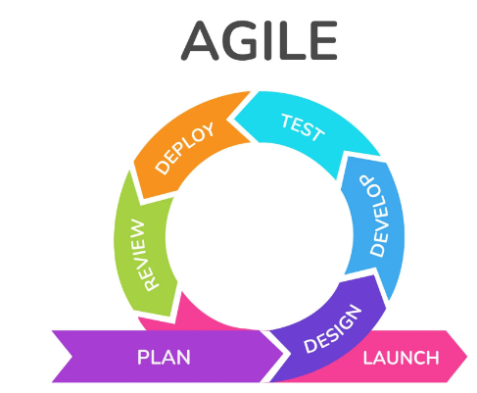1. **Agile:** An integrated process that works non-stop and complements each other and is continuous in developing products and releasing new products, allowing for segmentation as it is subject to change with the start of priority. It is considered more flexible to improve and reprioritize product backlogs so that it always delivers high quality products.

Agile methodology is characterized by its iterative and flexible approach to software development. It emphasizes collaboration among cross-functional teams and prioritizes adaptability to changing requirements throughout the development process.

Agile development is important because it helps to ensure that development teams complete projects on time and within budget. It also helps to improve communication between the development team and the product owner. Additionally, agile development methodology can help reduce the risks associated with complex projects.

2. **Compare between agile and waterfall models:**

|  |  |  |
| --- | --- | --- |
|  | Agile | Waterfall models |
| Advantage | Flexibility  Efficiency  Client Involvement | Easy to Understand  Predictability  Documentation |
| Disadvantage | Complexity  Lack of Predictability  Documentation  Critical path | Not flexibility  Inefficient  Client Involvement |
| When to Use it | Ideal for dynamic environments and continuous improvement initiatives, it is also used for divisible project tasks. | Is the best choice for projects with well-defined requirements and strict deadlines that are not divisible. When all the tasks of the first phase are completely completed, they move to the second phase, step by step without going back. |
| Practice | Projects that have competitors such as:  Apple ,bank ,omental | Projects that have no competitors such as:  organization |

3. **Frameworks agile:**

4. **Scrum**: is a framework for getting work done within agile. Scrum uses all the core principles of agile to define methods to facilitate a project. However, it is important to note that agile does not always mean Scrum. Many different methodologies take an agile approach to project management.

* Scrum roles:

Scrum in Agile requires particular roles and responsibilities. Each Scrum team member has a specific role to play, ensuring that everyone knows what they’re responsible for. The Scrum process includes the following roles:

1. Product owner: The product owner represents the customer’s best interest. This person has the ultimate authority over the final product.
2. Scrum master: This person is a facilitator, responsible for arranging the daily meetings, improving team interactions, and maximizing productivity.

* Scrum also relies on practices called Scrum artifacts to keep everything organized. There are three main Scrum artifacts:

1. Product backlog
2. Sprint backlog
3. sprint planning meeting

* Scrum timing;

A Scrum sprint cycle is a time boxed period when a team delivers a set amount of work. It is typically two to four weeks in duration and each sprint starts the moment the previous one is completed. The Scrum sprint cycle is often referred to as a process of continuous development.

* Scrum meeting:

1. Sprint planning meeting: A sprint planning meeting should be one of the longest Scrum meetings you hold—plan on two hours of planning for each week of your sprint.
2. Daily standup meeting; as the most frequently held Agile Scrum meetings, daily standup meetings are the bread and butter of Scrum sprints. They’re short, to the point, and, as the name suggests, held each day—they’re typically the first meeting of the work day.
3. Sprint review meeting; is are held at the end of each sprint. This meeting is an opportunity for you and your team to demonstrate what you’ve accomplished to the product owner and other stakeholders outside of your team.
4. Sprint retrospective meeting: Just like review meetings, a sprint retrospective meeting is held at the end of each sprint.
5. Product backlog refinement: This meeting is your chance to add clarifying details, establish deliverables, and prioritize the tasks in your backlog.